**TUTORIAL 9**

**EXERCISE**

Do the Risk Assessment for your project’s topic using given template.  
Note: You must find out at least 5-10 risks. More risks are recommended.

## **What is a Risk Assessment?**

A risk assessment identifies and evaluates the threats and risks of a specified situation. If you’re aware of a potential hazard, it’s easier to either reduce the harm it causes or (ideally) prevent it completely than to deal with the consequences.

## **How to Conduct a Risk Assessment?**

#### Step 1: Identify Hazards

Relating to your scope, brainstorm potential hazards. The list should be long and comprehensive and may include anything from falls and burns, to theft and fraud, to pollution and societal damage.

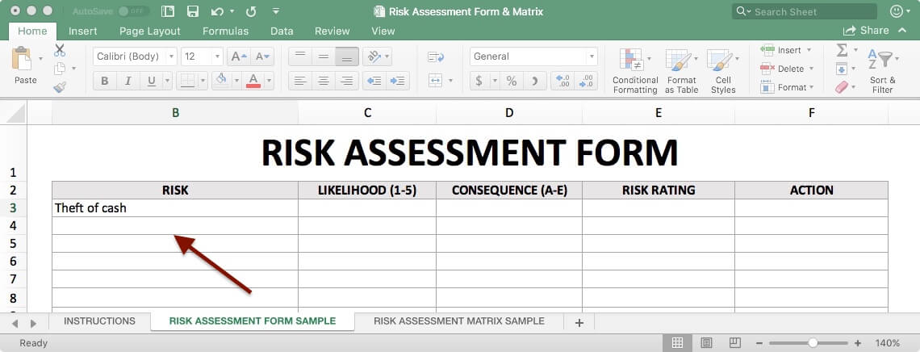

#### Step 2: Calculate Likelihood

For each hazard, determine the likelihood it will occur. This can be measured as a probability (a 90 per cent chance) or as a frequency (twice a year). Then, based on the likelihood, choose which bracket accurately describes the probability:

##### 1. Unlikely

An unlikely hazard is extremely rare, there is a less than 10 per cent chance that it will happen.

##### 2. Seldom

Seldom hazards are those that happen about 10 to 35 per cent of the time.

##### 3. Occasional

An occasional hazard will happen between 35 and 65 per cent of the time.

##### 4. Likely

A likely hazard has a 65 to 90 per cent probability of occurring.

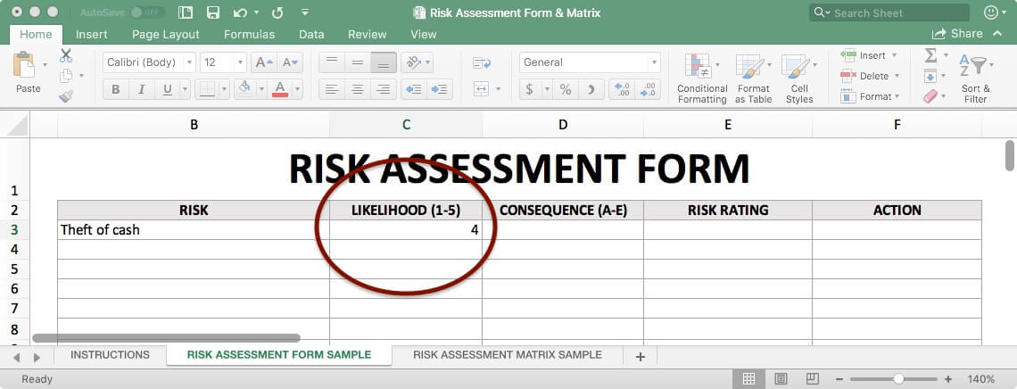

##### 5. Definite

These hazards will occur 90 to 100 per cent of the time. You can be nearly certain it will manifest.

#### Step 3: Calculate Consequences

In the same fashion as above, calculate potential loss using either quantitative measurements (dollar), qualitative measurements (descriptive scale) or a mix of both. Then, based on the magnitude of the consequences, choose which bracket accurately describes the losses:

##### A. Insignificant

The consequences are insignificant and may cause a near negligible amount of damage. This hazard poses no real threat. Examples: loss of $1K, no media coverage and/or no bodily harm.

##### B. Marginal

The consequences are marginal and may cause only minor damage. This hazard is unlikely to have a huge impact. Examples: loss of $10K, local media coverage and/or minor bodily harm.

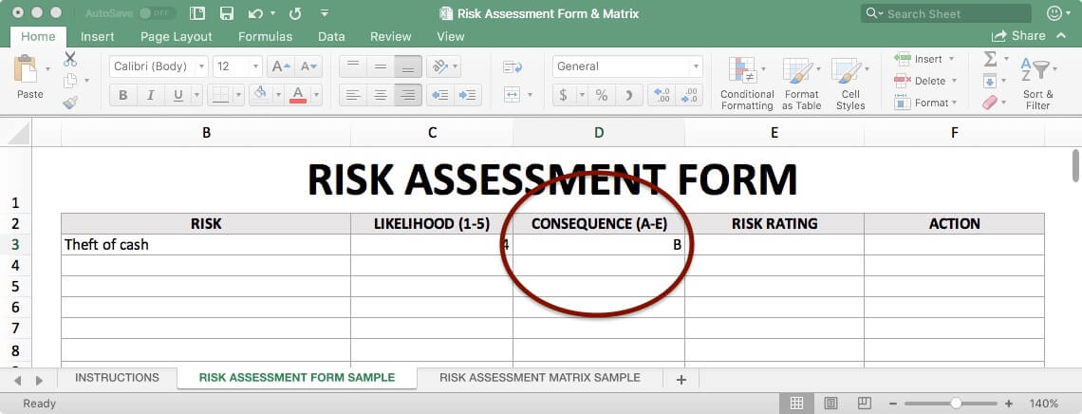

##### C. Moderate

The consequences are moderate and may cause a sizeable amount of damage. This hazard cannot be overlooked. Examples: loss of $100K, regional media coverage and/or minor bodily harm.

##### D. Critical

The consequences are critical and may cause a great deal of damage. This hazard must be addressed quickly. Examples: loss of $1M, national media coverage, major bodily harm and/or police involvement.

##### E. Catastrophic

The consequences are catastrophic and may cause an unbearable amount of damage. This hazard is a top priority. Examples: loss of $10M+, international media coverage, extreme bodily harm and/or police involvement.

#### Step 4: Calculate Risk Rating

Assign each hazard with a corresponding risk rating, based on the likelihood and impact you’ve already calculated. For example, a hazard that is very likely to happen and will have major losses will receive a higher risk rating than a hazard that’s unlikely and will cause little harm.

Risk ratings are based on your own opinion and divided into four brackets. They are:

##### Low

Low risks can be ignored or overlooked as they usually are not a significant threat. A definite hazard with insignificant consequences, such as stubbing your toe, may be low risk.

##### Medium

Medium risks require reasonable steps for prevention but they’re not a priority. A likely hazard with marginal consequences, such as a small fall, may be medium risk.

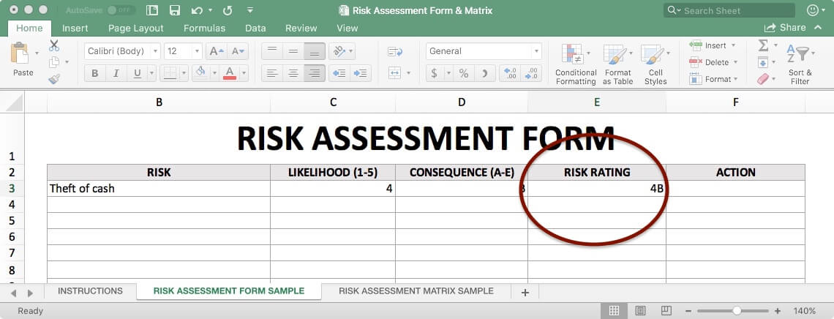

##### High

High risks call for immediate action. An occasional hazard with critical consequences, such as a major car accident, may be high risk.

##### Extreme

Extreme risks may cause significant damage, will definitely occur, or a mix of both. They’re a high priority. An unlikely hazard with catastrophic consequences, such as an aircraft crash, is an extreme risk.

#### Step 5: Create an Action Plan

Your risk action plan will outline steps to address a hazard, reduce its likelihood, reduce its impact and how to respond if it occurs.

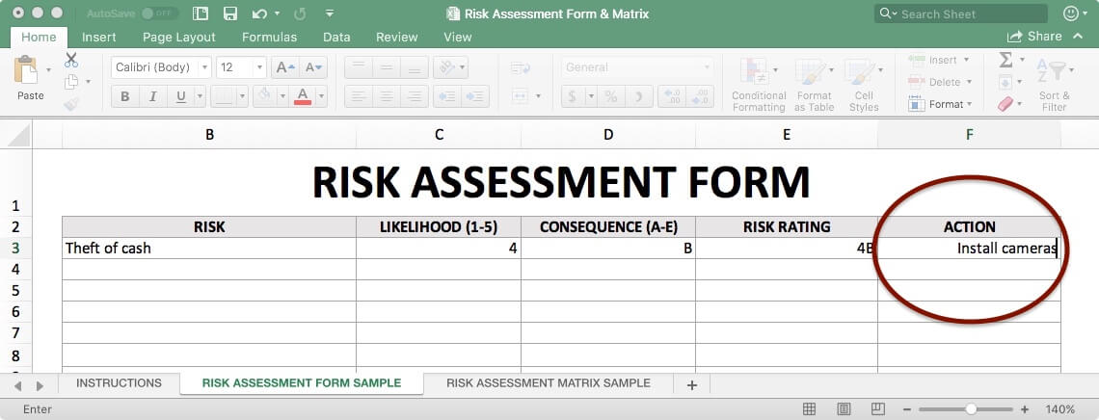

#### Step 6: Plug Data into Matrix

A risk assessment matrix simplifies the information from the risk assessment form, making it easier to pinpoint major threats in a single glance. This convenience makes it a key tool in the risk management process.

Every risk assessment matrix has two axes: one that measures the consequence impact and the other measures likelihood.

To use a risk matrix, extract the data from the risk assessment form and plug it into the matrix accordingly.

##### ****Green**** is low risk

##### ****Yellow**** is medium risk

##### ****Orange**** is high risk

##### ****Red**** is extreme risk

## **Health and Safety Risk Matrix Sample**

A health and safety risk assessment is important for industries like construction, manufacturing or science labs where work takes place in potentially dangerous environments.

In a warehouse, for example, workers are at risk of many hazards such as:

* Severe or fatal injury from falling
* Repetitive strain injuries from manual handling
* Sprains and fractures from slips and trips
* Being crushed by falling objects
* Being hit by (or falling out of) lift trucks
* Crush injuries or cuts from large machinery
* Moving parts of a conveyor belt resulting in injury
* Exposure to hazardous substances

Health and safety risk assessments must also include things like workplace violence and other dangerous employee misconduct.

## **Project Risk Matrix Sample**

Any project, event or activity must undergo a thorough risk assessment to identify and assess potential hazards. Once these risks are better understood, the team can make a prevention and mitigation plan to arm themselves against the hazard.

Brainstorm hazards in several categories such as:

* Technical (data breach)
* Cost (funding falls through)
* Contractual (modified requirements)
* Weather (natural disaster)
* Environmental (oil spill)
* People (illness, resignation)

**SUBMISSION:**- File format: Excel   
- File name: *FullName_StudentID_Class_SPM_Tut09*